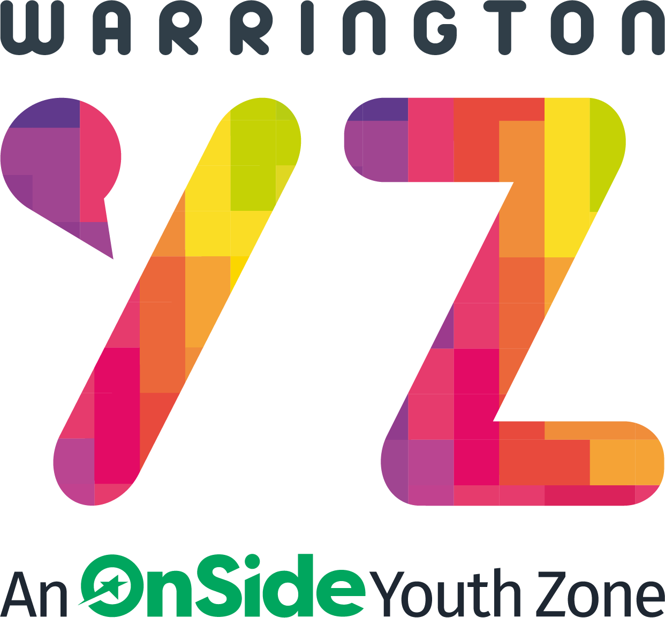

Warrington Youth Zone
Dallam Lane
Warrington
WA2 7NG
Tel: 01925 977277

Catering Role
Warrington Youth Zone has its own catering kitchen and Café. We not only serve our members but also cater for events and conferences. Our amazing £1 meal offer is available every single day in the youth zone. We are looking for someone to join the team to work in the kitchen and serve in the Café. This role does require a Level 2 Food Hygiene certificate although we can support successful candidates to achieve this.
HOURS:
Typical shifts are:
Mon, Wed, Fri: 16:30-20:30
Tue, Thu: 15:30-19:30
Sat: 11:00–15:00 and 16:30–20:30
Ideally a minimum of 9 hours per week but we can be flexible so please discuss with us.
CONTRACT:
Age dependent National Minimum Wage
Pension contribution of 3% once the earnings threshold is reached.
Hourly staff - annual leave will be calculated at 14% of hours worked on a rolling basis.
KEY RESPONSIBILITIES
- To undertake the preparation of food and beverages served in the café area as well for events and conferences.
- To serve food and beverage to our members, ensuring they receive a great level of customer service.
- To ensure all Health & Safety and Environmental Health requirements are adhered to, namely:
- reporting of all faulty equipment
- reporting of any health & safety issues
- compliance with food hygiene regulations, in particular ensuring food is stored appropriately and at correct temperatures, and record all high-risk food temperatures on delivery and prior to service
- all kitchen equipment, storage areas and surfaces are cleaned and sanitised, floors are swept and mopped, as necessary.
- Report any kitchen equipment faults or need for repair
- To assist with the production of and costing of menus.
- To comply with stock control procedures.
- To assist with the ordering and control of all stock
- Cash handling in line with financial procedures.
- Undertake such other additional duties which may result from changing circumstances.
APPLICATION PROCESS
To apply, please send complete the application form and return to recruitment@wyz.org.uk or apply via our website at Work for Us. In addition, please let us know of any reasonable adjustments we can make to assist you in your application or the selection process.
In accordance with our Child Protection and Safeguarding procedures, this position requires an Enhanced DBS check.
For information regarding how we process your data, go to https://warringtonyouthzone.org/privacy-policy/
APPLICATION CLOSING DATE: 23rd February 2026
APPLICATION INTERVIEW DATE: TBC
Job Types: Part-time, Permanent
Work Location: In person
Warrington Youth Zone reserves the right to close this vacancy early, if a number of suitable applications are received.

