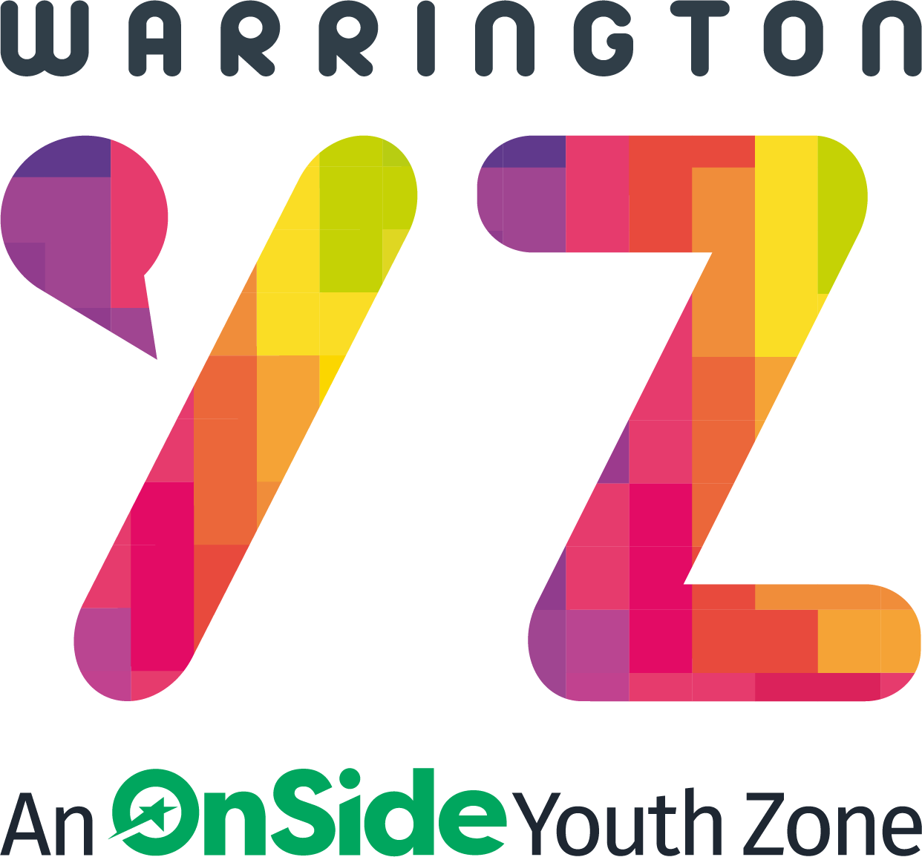

Warrington Youth Zone
Dallam Lane
Warrington
WA2 7NG
Tel: 01925 977277

Satellite Club Youth Worker

Warrington Youth Zone has "Satellite" youth clubs within the community, offering a youth work provision for young people that is closer to home and easier for them to access. These are typically based within local community centres and they do their best to offer everything that is available at the Youth Zone in the town centre.

The clubs offer a wide range of activities, from sports, games and challenges to arts, crafts and baking. As a member of the team, you will be key in ensuring young people have access to an exciting and engaging programme, making it a fun and safe environment for them to be themselves and explore skills.

The post holder will be responsible for creating a lively, dynamic, creative and fun-loving environment for all young people, whilst also creating space for young people to explore and discuss some of the big issues of the day.

We are recruiting 2 Youth Workers to work on a Friday evening from 4.30p.m. – 8.30p.m. (transport to and from the satellite venue is available from Warrington Youth Zone.)

These are fixed term positions available until 31st August 2026.

KEY RESPONSIBILITIES

- Deliver outreach activities to connect with young people in various community settings, that are exciting, safe, varied, innovative, developmental and directly responds to the diverse needs, concerns and interests of the young people.
- Build relationships with at-risk youth and provide individualised support to address and support their needs.
- Organise and facilitate group activities, workshops and events to promote positive youth engagements with the most hard to reach young people of Warrington.
- Work collaboratively with police, local authority, business owners and other members of the community, to coordinate resources and service requirements relating to young people.
- Monitor and evaluate the progress of youth participants and report interventions, successes and challenges of the programme to the funders.
- Be a role model for young people and present a positive “can do” attitude.
- Understand the principles of working with children and young people, the issues affecting their lives and knowledge of their needs, specifically in a street-based capacity.
- To directly deliver a high-quality programme of activity
- To establish positive relationships with children and young people.
- To promote and safeguard the welfare of children and young people at all times.
- Be an advocate for Warrington Youth Zone, demonstrating the values at all times.
- Respond appropriately to a variety of situations, including reporting to emergency services where necessary.
- Be a presence across Warrington whilst on shift, representing Warrington Youth Zone in all boroughs.
- Have a knowledge of relevant agencies and services in order to signpost young people to the right support for them.

Salary: National Minimum Wage:

Category | 2025/26 Payrate
Ages 21 and over | £12.21 per hour
Ages 18 - 20 | £10.00 per hour
Under 18’s | £7.55 per hour

APPLICATION PROCESS
To apply, please send an up-to-date CV to recruitment@wyz.org.uk or apply via our website at Work for Us. In addition, please let us know of any reasonable adjustments we can make to assist you in your application or the selection process.
In accordance with our Child Protection and Safeguarding procedures, this position requires an Enhanced DBS check.
For information regarding how we process your data, go to https://warringtonyouthzone.org/privacy-policy/
APPLICATION CLOSING DATE: 6th March 2026
APPLICATION INTERVIEW DATE: TBC
Job Types: Part-time, Fixed term
Work Location: In person
Warrington Youth Zone reserves the right to close this vacancy early, if a number of suitable applications are received.
Internal applications:

Please complete the ‘Expression of Interest Form’ and return this to: recruitment@wyz.org.uk

