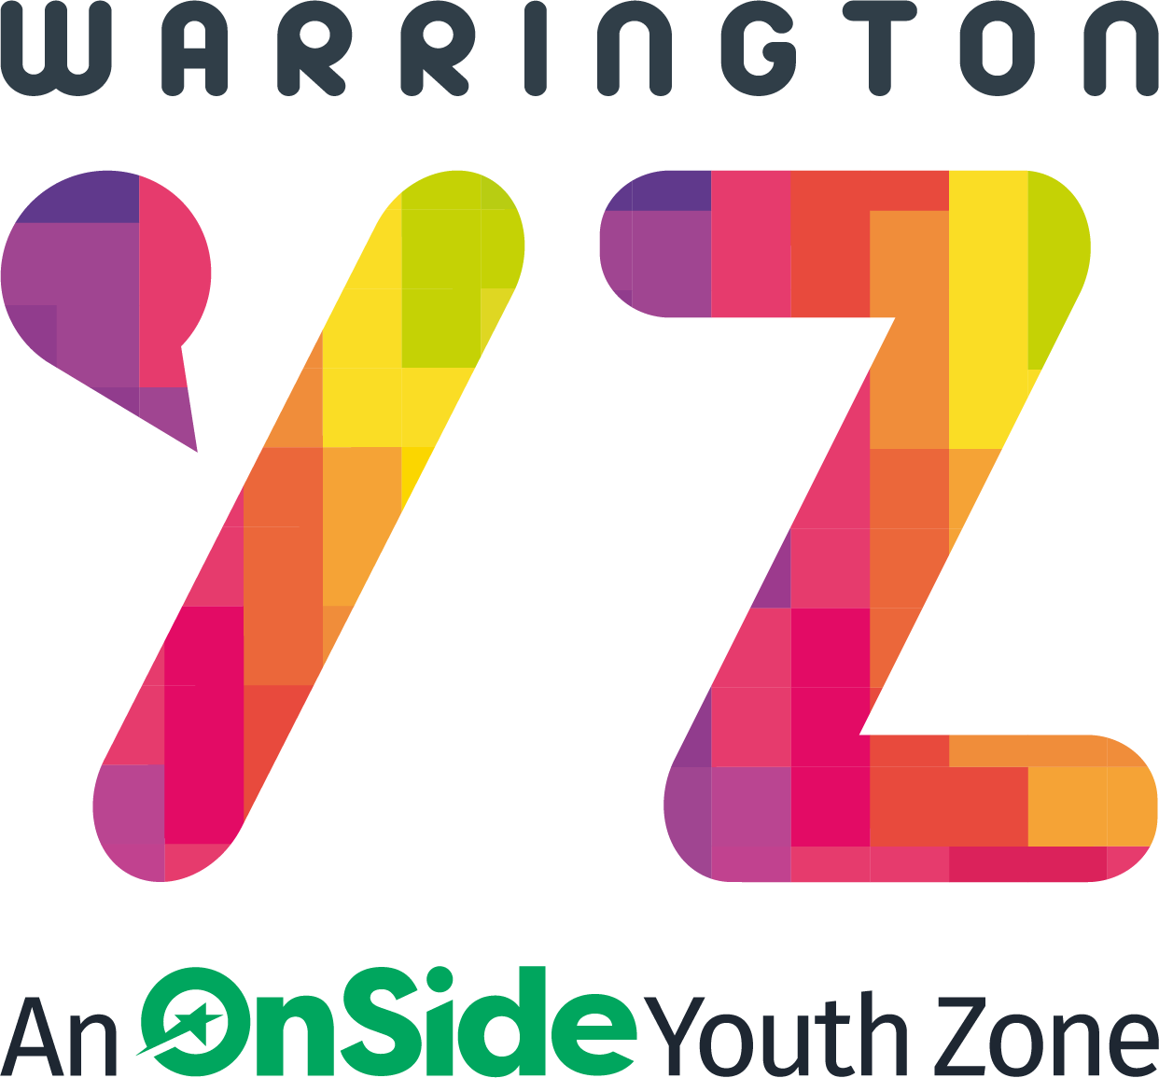

Warrington Youth Zone
Dallam Lane
Warrington
WA2 7NG
Tel: 01925 977277

Job Description:

ROLE OVERVIEW

The ‘rec area’ is at the heart of Warrington Youth Zone’s junior offer to young people aged between 7 and 12 years old. Do you want to use your passion, imagination and talents to make the lives of young people better? We are looking for someone who is passionate about socialising, engaging and developing young people’s minds as they grow? Are you vibrant, creative and committed to adapting to meet the individual needs of young people enabling effective engagement in both small and large group activities. The programme is wide ranging, and no day is ever the same. As a member of this dynamic team, you will be key in ensuring young people have access to positive play opportunities. THE PERSON The post holder will be responsible for creating a lively, dynamic, creative environment for all young people, whilst of course having FUN!

RATE OF PAY:
Warrington Youth Zone commits to paying the National Minimum Wage
- Aged 21 + over £12.21
LOCATION:
Warrington Youth Zone (Dallam Lane, WA2 7NG)

REPORTING TO:
Junior Lead

CONTRACT:
Permanent: Part time hours available on
- Thursday - 3.45pm - 8.15pm
- Saturday - 11.45am - 4.15p.m.
KEY RESPONSIBILITIES
Together with the Junior Club Manager you will develop and implement a recreational programme that is exciting, challenging and ever-changing for young people aged between 7 and 12 years old. To provide activities to allow young people to engage in positive play opportunities
To provide activities to allow young people to engage in positive play opportunities
This role is 100% direct face to face delivery with young people to develop their social skills
To directly deliver a high-quality programme of activity that is exciting, safe, varied, innovative, developmental and respond to the diverse needs, concerns and interests of the members.
To have great energy and establish positive relationships with young people, the wider youth work team, and visitors to the Youth Zone
To respond to the needs of young people through activities in the recreation area
To support and motivate volunteers working in the recreation area
To work flexibly to ensure the needs of the members are met, including disadvantaged young people and those with additional needs.
To ensure that the members maintain a high standard of behaviour and discipline during sessions by making the area a hub of activity and fun.
To ensure the participation of young people in activities and ensure that their ideas contribute fully in the delivery of activities in a safe way.
To be able to think on your feet and create a fun activity with minimal equipment.
To promote cultural cohesion and inclusion and proactively challenge any prejudice and discrimination
To be a role model for young people and present a positive “can do” attitude.
To take personal responsibility for own actions Commit to a culture of continuous improvement. To work within the performance framework of Warrington Youth Zone and Onside Network.
To comply with all policies and procedures, with particular reference to Safeguarding, Codes of Conduct, Health and Safety, Equality and Diversity to ensure all activities are inclusive, safe and accessible to all.
To be alert to issues of safeguarding and child protection, ensuring the welfare and safety of Youth Zone members is promoted and safeguarded, and to report any child protection concerns to the designated Safeguarding Lead using the safeguarding policies, procedures and practice (training to be provided).
To represent Warrington Youth Zone positively and effectively in all dealings with internal colleagues, and external partners.
To actively promote the Youth Zone and positively contribute towards increasing Youth Zone membership.
Any other duties as may reasonably be required.

BENEFITS:
Pension contribution of 3% once the earnings threshold is reached.
Hourly staff - annual leave will be calculated at 14% of hours worked on a rolling basis.

APPLICATION PROCESS
To apply, please complete and return the application form to recruitment@wyz.org.uk In addition, please let us know of any reasonable adjustments we can make to assist you in your application or the selection process.

In accordance with our Child Protection and Safeguarding procedures, this position requires an Enhanced DBS check.

For information regarding how we process your data, go to
https://warringtonyouthzone.org/privacy-policy

APPLICATION CLOSING DATE: 12th April 2026
Warrington Youth Zone reserve the right to close this vacancy early should a sufficient number of suitable applications be received.

APPLICATION INTERVIEW DATE: TBC

