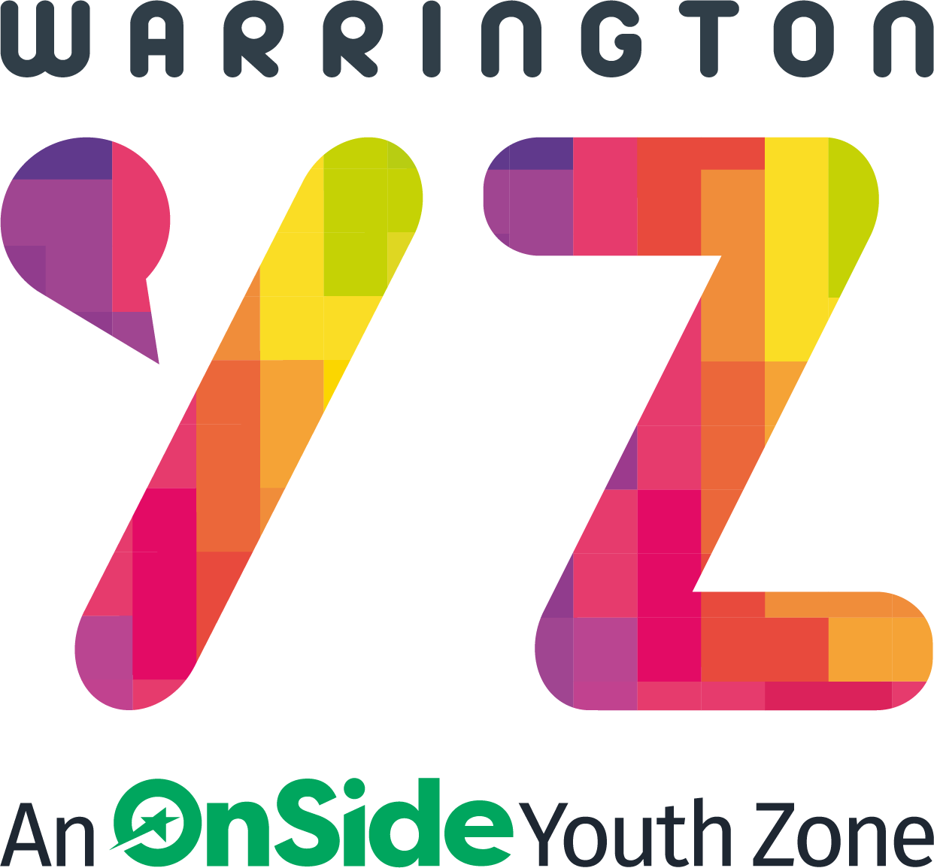

Warrington Youth Zone
Dallam Lane
Warrington
WA2 7NG
Tel: 01925 977277

Sports Youth Worker

Warrington Youth Zone is looking to recruit a number of Sport Sessional Youth Workers across our Boxing Gym, Sports Hall, MUGA, Fitness Gym and Climbing Wall.

Within the Sports Team, we are looking for talented sports and fitness enthusiasts to become part of a team with a wide range of skills, who are also passionate about working with young people. This role offers a fantastic opportunity to make a positive impact on young people’s lives through the power of sport. If you are enthusiastic, dedicated, and ready to inspire the next generation, we would love to hear from you!

Sport is at the heart of Warrington Youth Zone’s offer to young people. The Sports offer is wide ranging and as a member of the Sports team, you will be key in ensuring young people have access to an exciting and engaging programme of multi-disciplinary activities that will be challenging, stimulating, fun, engaging and developmental.

Job Responsibilities and Information

This role is 100% face-to-face delivery with young people, and you will work directly with young people to plan, lead and deliver safe, fun and structured sports/fitness sessions within Warrington Youth Zone, which are progressive and reflect the needs of young people.

Key Responsibilities as a Sports Youth Worker
- To contribute to a sports/fitness programme that is high quality and meets the needs of the young people, including young people with additional needs and young people who typically don’t engage in sports
- To support a sports/fitness programme that contributes to the wider youth work agenda, supporting the development of young people
- To confidently manage and establish positive relationships with groups of young people
- To compile all monitoring information required to deliver impact statistics and encourage feedback from young people taking part in activities to share this with the team.
- To work with young people from a range of backgrounds and with a range of needs
- Effectively communicate at all levels, orally and in writing
- To work alongside other team members and provide guidance and support to young leaders and volunteers
- To attend regular training and development sessions and events where required
- To deliver leadership awards to young people and co-ordinate volunteering opportunities in sports/fitness activities
- To encourage attendance in sports/fitness activities, particularly by young people who do not usually participate in sport/fitness activities
- To assist in identifying talented young people and encourage further development
- To maintain current knowledge of relevant National Governing Body programmes, policies and practices
- To promote cultural cohesion and inclusion and proactively challenge any prejudice and discrimination
- To assist with any promotional activities and visits that take place at the Youth Zone
- Be a role model for young people and present a positive “can do” attitude
- Take personal responsibility for own actions and commit to a culture of continuous improvement
- Work within the performance framework of Warrington Youth Zone and OnSide
- Comply with all policies and procedures, with particular reference to safeguarding, codes of conduct health and safety and equality and diversity to ensure all activities are accessible
- To be alert to issues of safeguarding and child protection, ensuring the welfare and safety of Youth Zone members is promoted and safeguarded, and to report any child protection concerns to the designated Safeguarding Lead using the safeguarding policies, procedures and practice (training to be provided)
- Represent Warrington Youth Zone positively and effectively in all dealings with internal colleagues, and external partners
- To actively promote the Youth Zone and positively contribute towards increasing Youth Zone membership
- Any other duties which may reasonably be required

Person Specification

Applicants will be expected to demonstrate the experience, skills, abilities and attributes listed.

Experience
Experience | Requirement
Experience of working with groups of young people aged 8 to 19, or up to age 25 with additional needs | Essential
Experience of working with young people from diverse backgrounds and with challenging needs | Essential
Experience of delivering a wide range of sports or activity sessions | Essential
Experience of team working and alongside volunteers | Essential
Experience of working with young people with additional needs | Desirable
Experience of delivering events and competitions | Desirable
For Climbing Wall only – previous climbing experience | Essential

Skills, Knowledge and Attributes
Skills, Knowledge and Attributes | Requirement
Ability to deliver high quality fitness programmes with young people who face social exclusion, disadvantage and disaffection and manage such a group | Essential
Ability to plan and create interesting & fun sessions for young people | Essential
Able to work as part of a team and under own initiative | Essential
Able to support the planning and evaluation of programs of activity including production of session plans and program reports | Essential
Able to communicate effectively with young people, parents, team members and members of the public | Essential
Able to deliver within an equal opportunity’s framework | Essential
Ability to engage and build positive relationships with young people including disengaged and disadvantaged young people | Essential
Ability to coach, encourage, motivate and provide reliable support to young people | Essential
Understand the principles of working with young people, the issues affecting their lives and knowledge of their needs | Essential
Knowledge of health and safety, diversity awareness and safeguarding best practice | Essential
Basic knowledge of sports pathways | Desirable

Qualifications
Qualifications | Requirement
For Fitness Gym Only – Level 2 Gym Instructing or above | Essential
GCSE or equivalent literacy and numeracy | Desirable
Evidence of ongoing professional development | Desirable
First Aid Qualification | Desirable
Sports qualifications in sports such as football, rugby, basketball, badminton, tennis etc | Desirable
Experience of delivering events and competitions | Desirable

Special Requirements
Special Requirements | Requirement
A willingness to work unsociable hours | Essential
A willingness to cover events, holidays and staff | Essential
Enhanced DBS clearance. Commitment to Safeguarding children | Essential

Salary
National Minimum Wage:

Category | 2025/26 Payrate
Ages 21 and over | £12.21 per hour
Ages 18 - 20 | £10.00 per hour
Under 18’s | £7.55 per hour

Application Process
To apply, please complete the application form and return to recruitment@wyz.org.uk or apply via our website at Work for Us. In addition, please let us know of any reasonable adjustments we can make to assist you in your application or the selection process.
In accordance with our Child Protection and Safeguarding procedures, this position requires an Enhanced DBS check.
For information regarding how we process your data, go to https://warringtonyouthzone.org/privacy-policy/
APPLICATION CLOSING DATE: TBC
APPLICATION INTERVIEW DATE: TBC
Job Types: Part-time, Permanent
Work Location: In person
Warrington Youth Zone reserves the right to close this vacancy early, if a number of suitable applications are received.
Internal applications: Please complete the ‘Expression of Interest Form’ and return this to: recruitment@wyz.org.uk

