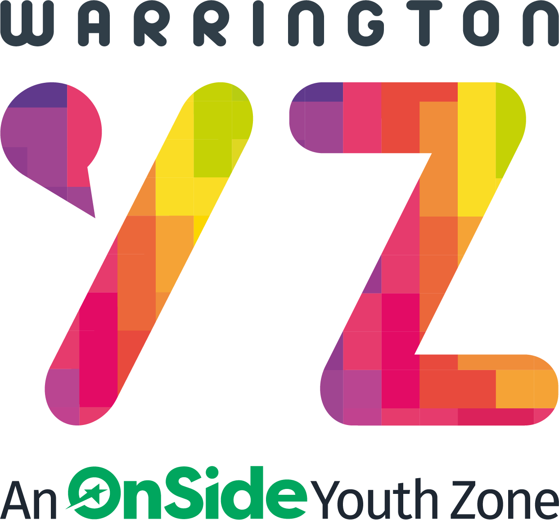

Warrington Youth Zone
Dallam Lane
Warrington
WA2 7NG
Tel: 01925 977277

Job description:

POST:
Mental Health Support Worker – ‘Youth in Mind’

SALARY: £12.70 per hour

LOCATION:
Warrington Youth Zone, Dallam Lane, Warrington & Various Satellite Locations

REPORTING TO:
Mental Health Manager

CONTRACT: Fixed term until end March 2026;
Tuesday – at Warrington Youth Zone – 3.15p.m. – 7.45p.m.
Friday – at our Satellite base in Culcheth - 4.30p.m. – 8.30p.m.
Saturday – at Warrington Youth Zone – 3.15p.m. – 7.45p.m.
Sunday - at Warrington Youth Zone – 10.45a.m. – 3.15p.m.
20hrs per week (18 hrs delivery + 2 hrs planning)

BENEFITS:
· Pension contribution of 3% once the earnings threshold is reached.
· Hourly staff - annual leave will be calculated at 14% of hours worked on a rolling basis.

THE ROLE
The Mental Health Support Worker for ‘Youth In Mind’ will support the Targeted Team in delivering an effective, structured wellbeing programme to children and young people from across Warrington.
You will be responsible for working on our Youth In Mind Mental Health programme, offering one-to-one and group wellbeing sessions to young people requiring a high level of support as part of a drop-in service in various locations. You will be required to triage young people’s needs in order to signpost them to an appropriate service, either internally within the Youth Zone or to an external provider.
The service is commissioned by Cheshire & Merseyside NHS as part of ‘Warrington Place’ Starting Well and plans to support ‘Children and Young Peoples Emotional and Mental Health & Wellbeing’. The project delivery is a partnership between Warrington Youth Zone and Merseycare ‘Child & Adolescent Mental Health Services’ (CAMHS).
Meeting targets as outlined by funders, contracts, and the Head of Targeted Programmes is a significant element of this role to ensure the quality of support young people receive to achieve outcomes.
This post involves a commitment to the completion of all relevant paperwork, reports and recording processes ensuring they are both accurate and timely. Ensuring that monitoring and evaluation forms are completed with young people.

GENERAL INFORMATION
These Mental Health Support Worker positions are Fixed term until end March 2026. There will be Monday-Sunday rota shifts available with various working hours being between 15:00-21:00 at various location across Warrington. This will mean working flexibly across the week, at different locations to suit the needs of both the role and the individual.

APPLICATION PROCESS:
External applicants – To apply, please complete the application form and return to: recruitment@wyz.org.uk - application form and full role description found at:
https://warringtonyouthzone.org/get-involved/vacancies/
Please note – we will not be accepting CV’s for these roles.

Closing Date: 30th December 2025

In addition, please do let us know of any reasonable adjustments we can make to assist you in your application or the selection process.

In accordance with our Child Protection and Safeguarding procedures, this position requires an

Enhanced DBS check

KEY RESPONSIBILITIES
To manage and ‘triage’ the needs of the young people requiring 1-1 support for their emotional health.
To provide a safe, community space where young people can talk openly about their mental health free from stigma and judgement.
To empower and encourage young people to access both internal and external support for their emotional health.
To have awareness and knowledge of local and national organisations that can be signposted as providing emotional and mental health support.
To enable conversations through active listening, helping young people to access support and information and exploring effective ways of improving wellbeing.
To identify, understand and help someone who is struggling with their mental/emotional health.
To work to a rota including set evening and weekends in line with the role and team requirements.
To ensure that sessions are recorded in an accurate and timely way on in-house systems.
To ensure monitoring and evaluation forms are completed with young people
To adopt a proactive, flexible approach towards engaging young people across the Youth Zone
To champion our Values, challenging any negative and discriminatory behaviours
To ensure that work practice and delivery operates within Every Child Matters outcomes, Safeguarding policies, and Health and Safety policies.
To travel to different locations as required for the role.
To attend and participate in regular team meetings and undertake training and/or additional qualifications as required.
To undertake any other work requested by your line manager that relates to the role.

Job Types: Part-time, Fixed term contract
Contract length: 3 months

