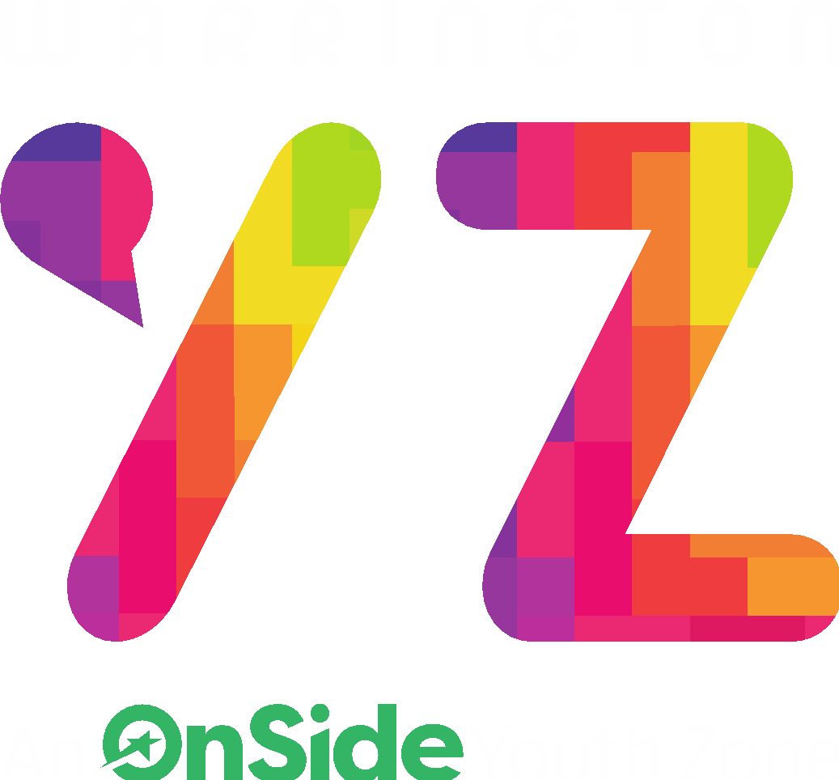
ROLE PROFILE
Mental Health Administrator Support

ROLE PROFILE
POST:

Mental Health Administrator Support

SALARY:

£11.94 per hour

LOCATION:
Warrington Youth Zone, Dallam Lane, Warrington
REPORTING TO:

Mental Health Lead

CONTRACT:

12-month fixed term until April 2025; Monday – Sunday flexible working hours 16 hours per week
BENEFITS:
- Pension contribution of 3% once the earnings threshold is reached.
- Part time roles will receive pro-rata allocated annual leave based on 33 days FTE Including Bank Holidays).
- Hourly staff - annual leave will be calculated at 14% of hours worked on a rolling basis.

THE ROLE
The Mental Health Administrator Support is a vital role and will support the running of the Mental Health & Wellbeing offer at Warrington Youth Zone. You will be a key part of the Mental Health & Wellbeing team who work with young people on a 1-2-1 and group basis helping to address the needs of the young people.

The role requires you to provide robust, accurate and timely administration support to the Mental Health Lead to ensure the smooth running of the programme and administration process. Duties will include but are not limited to salesforce, spreadsheets, resource gathering, promotion of the service and reports.

This post involves a commitment to the completion of all relevant paperwork, reports and recording processes ensuring they are both accurate and timely.

GENERAL INFORMATION

These Mental Health Support Worker positions are Fixed term until April 2025.

There will be Monday – Sunday flexible working hours 16 hours per week.

This will mean working flexibly across the week, to suit the needs of both the role and the individual.

APPLICATION PROCESS

Internal applicants – To apply please request an internal application form.

External applicants – To apply, please complete the application form and return to: recruitment@wyz.org.uk

In addition, please do let us know of any reasonable adjustments we can make to assist you in your application or the selection process.

In accordance with our Child Protection and Safeguarding procedures, this position requires an Enhanced DBS check

KEY RESPONSIBILITIES
- Administration of the Youth In Mind programme and reporting to the NHS Mersey Care MHSTDS (Mental Health Services Data Set) standards

- To support the Youth In Mind team by auditing record keeping within Salesforce for documenting and uploading all case notes from interactions with young people on the programme

- Analysis of data for identification of themes from interactions with young people, forming statistics and infographics demonstrating findings

- Maintenance of monthly reporting dashboards
- Commit to a culture of continuous improvement

- Work within the framework of Warrington Youth Zone and Onside.
- To actively promote Warrington Youth Zone and positively contribute towards increasing Warrington Youth Zones memberships.
- To ensure that sessions are recorded in an accurate and timely way on in-house systems.
- Comply with all policies and procedures, with particular reference to safeguarding, codes of conduct, health and safety and equality and diversity to make sure all activities are accessible.
- To champion our Values, challenging any negative and discriminatory behaviours
- To ensure that work practice and delivery operates within Every Child Matters outcomes, Safeguarding policies, and Health and Safety policies.
- To attend and participate in regular team meetings and undertake training and/or additional qualifications as required.
- To undertake any other work requested by your line manager.
- To support promotion of Warrington Youth Zone and the programmes ran with specific focus on our mental health offer.
- To support the Mental Health Lead with any administrative processes as required.
- Take personal responsibility for your actions.

PERSON SPECIFICATION
Applicants will be expected to demonstrate the experience, skills, abilities and attributes listed.

SELECTION CRITERIA | REQUIREMENT
EXPERIENCE
Administration and customer service experience | Essential
Proficient use of IT programmes such as Microsoft packages data bases systems and IT management software | Essential
Excellent planning and organisational skills will the ability to use initiative and achieve set outcomes | Essential
Experience of working with the general public | Essential
Experience of working with young people | Desirable
SKILLS, KNOWLEDGE AND ATTRIBUTES
Ability to hold confidential information and work towards a high threshold of confidentiality | Essential
Knowledge of computers and relevant software such as Microsoft packages | Essential
A commitment to inclusive practices and equality of opportunity for all | Essential
Excellent communication and interpersonal skills | Essential
Attention to detail, be thorough and organised. | Essential
Initiative and ability make decisions under pressure | Essential
Self-motivation to work set deadlines to meet project targets and reporting deadlines | Essential
Ability to analyse data, identify themes and produce statistics | Essential
QUALIFICATIONS AND TRAINING
Relevant experience working with young people | Essential
GCSE in Maths in English or equivalent | Essential
Evidence of interest in ongoing professional development  (for example, Safeguarding, Health & Safety, Project Management) | Essential
Willingness to undertake further training as required | Essential
SPECIAL REQUIREMENTS
A willingness to work unsociable hours (evenings until 7.45pm) | Essential
Be willing to learn new essential systems | Essential
A willingness to cover events, holidays and staff absence | Essential
DBS clearance and committed to Safeguarding children | Essential

