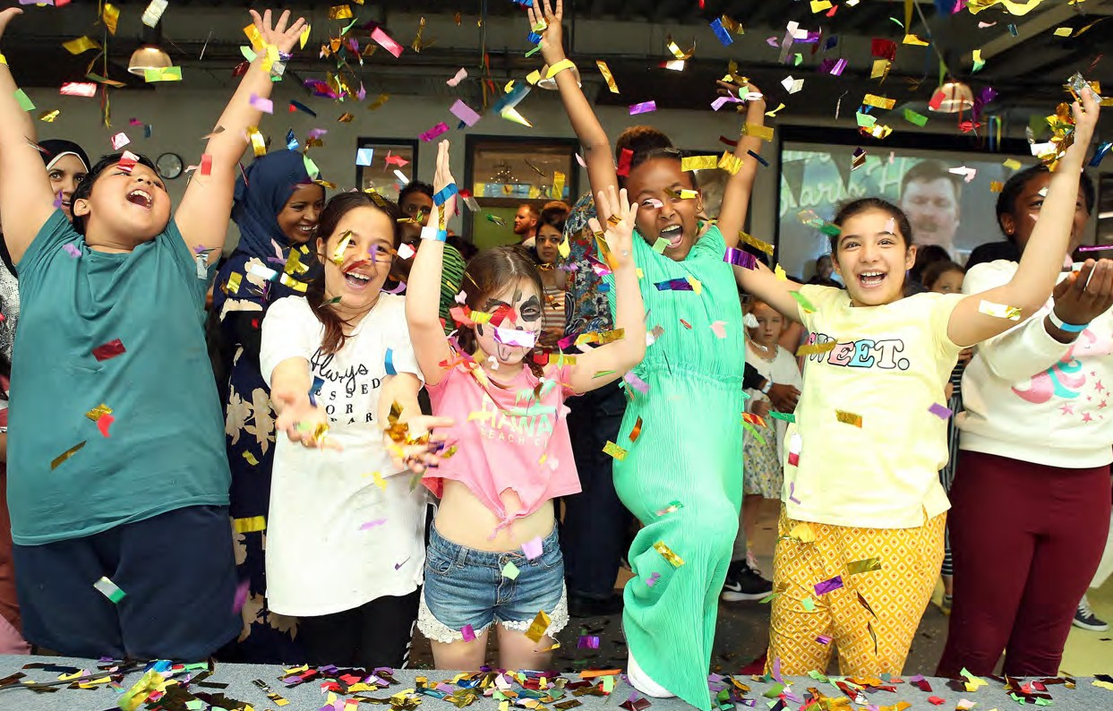

Sessional & Part Time Youth Worker & Activity Leads

Youth Worker: Health & Well-being

(this is diverse role ranging from running beauty session, delivering life skills, issues based youth work & single gender work)

**ROLE PROFILE**

## POST:

## Health & Well-being / Beauty / Project Worker

## SALARY:

£10.00 *p.h - £10.45 p.h*

## LOCATION:

Warrington (Dalham Lane)

**REPORTING TO:**

Youth Clubs Managers & Coordinators

## CONTRACT:

Permanent: Part time from 8 to 24 hours a week

BENEFITS:

5% matched contribution pension; 33 days holiday inclusive of Bank Holidays (rising with length of service)

THE PERSON

You will be a Youth Worker committed to working with and creating positive relationships with children and young people, delivering project and issue-based work as well as general health and well-being programmes.

You will be passionate about creating exciting and fun activities, leading single gender work, or running health or beauty sessions. You will be based primarily in our health and well-being room, which doubles as a hair and beauty space for all young people and be central and providing a wide-ranging programme to young people.

**WARRINGTON YOUTH ZONE**

Opening in Spring 2022 Warrington Youth Zone will become the new home and evolution of Warrington Youth Club (WYC). WYC was formed in 1930 by a group of parents who were concerned that their children were getting into trouble after school. Over the following five years the group developed into Warrington Boys Club. Warrington Youth Club today is a well-established charity which delivers an open

access Youth Club four nights a week at The Peace Centre, a satellite gym 7 days a week in Warrington Town Centre as well as a wide range of successful

targeted projects including mentoring, employability, and National Citizenship Service (NCS).

In 2008, the Board of WYC, recognising the need for WYC to modernise and evolve and find more permanent locations for its services (currently scattered over multiple locations), began

working closely with OnSide and Warrington Borough Council to explore the potential for a new Youth Zone, a central facility within Warrington which will allow the youth offer to be extended to 7 days each week and attract young people from across Warrington. Whilst providing a base for the many successful and changing targeted projects Warrington Youth Club deliver to local young people. Warrington Youth Club/Zone is part of the OnSide Network.

Warrington has a population of 210,000 people, 32,000 of whom fall within the target age for a Youth Zone (7 – 19 or up to 25 for those with a disability or vulnerability). There is currently no universal youth

provision for young people in Warrington available 365 days a year and Warrington Youth Club is the largest children and young people’s organisation in the town with over 4000 members.

Warrington Youth Club has a long history in helping young people in this area and is well networked into the Voluntary, Statutory, Faith and Private sectors across the Borough. The multi-agency links that Warrington Youth Club has developed will ensure that the new Youth Zone is accessible to a broad range of groups who support children and young people across

Warrington.

Warrington Youth Zone will be dedicated to young people and makes a bold statement about the importance of giving young people high quality places to go in their leisure time. Open 7 days a week including school holidays, the Youth Zone’s purpose is to help young people grow to be happy, healthy and successful adults.

The state-of-the-art £7.05 million building will

provide young people with facilities that are second to none delivering over 20 sporting, artistic, cultural and general recreational activities each session. Offering young people the opportunity to try new things, meet new friends and gain support from friendly, warm and positive staff and volunteers.

With every workout or kickabout, every mock interview or muck around with mates, young people develop the resilience to face challenges and the skills to solve problems. They find confidence to aim high and the determination to become who they want to be. They build positive relationships based on being given the space to talk, an understanding of their own self-worth, and a sense of belonging to something bigger. That is why Warrington Youth Zone won’t just be a place to go – but a place to grow. That is the power of exceptional youth work.

**THE ROLE**

Our targeted youth work and projects, alongside arts and sport are at the heart of Warrington Youth Zone’s offer to young people. Feedback from young people tells us that some young people want dedicated and safe spaces within their Youth Zone, this might be for signal gender work, LGBTQ+ groups or simply a safe space to talk and share. This role is based in the health and well-being room (which is equipped with hairdressing and barbers chairs and a nail station) and you will work with all young people to provide a wide range of opportunities from informal education sessions, wellness projects, advice and support and the more traditional health and beauty pastimes, which may include young people exploring health and beauty as a career path.

|  |
| --- |
| **KEY RESPONSIBILITIES** |
| * Together with the Junior/Holiday Club Co-ordinator and Senior Club Co-ordinator, develop and implement a programme that is exciting, challenging and ever changing |
| * To deliver targeted sessions to young people, ranging from informal education sessions to hair and beauty |
| * To deliver single gender work |
| * The role is 100% face to face delivery with young people |
| * To work directly with young people to develop their social skills |
| * To directly deliver a high-quality programme of activities that are exciting, safe, varied, innovative, developmental and directly responds to the diverse needs, concerns and interests of the members |
| * To have great energy and establish positive relationships with young people, the wider youth work team and visitors to the Youth Zone |
| * To respond to the needs of young people through activities and project work |
| * To support and motivate volunteers |
| * To work flexibly to ensure the needs of the members are met, including disadvantaged young people and those with disabilities or additional needs |
| * To ensure that the members maintain a high standard of behaviour and discipline during sessions by making the area a hub of activity and fun |
| * To ensure the participation of young people in activities and that their ideas contribute fully in the delivery of activities in a safe way |
| * To promote cultural cohesion and inclusion and proactively challenge any prejudice and discrimination |
| * Be a role model for young people and present a positive “can do” attitude |
| * Take personal responsibility for own actions |
| * Commit to a culture of continuous improvement |
| * Work within the performance framework of Warrington Youth Zone and OnSide |
| * Comply with all policies and procedures, with particular reference to safeguarding, codes of conduct health and safety and equality and diversity to ensure all activities are accessible |
| * To be alert to issues of safeguarding and child protection, ensuring the welfare and safety of Youth Zone members is promoted and safeguarded, and to report any child protection concerns to the designated Safeguarding Lead using the safeguarding policies, procedures and practice (training to be provided) |
| * Represent Warrington Youth Zone positively and effectively in all dealings with internal colleagues, and external partners |
| * To actively promote the Youth Zone and positively contribute towards increasing Youth Zone membership |
| * Any other duties as may reasonably be required |

# PERSON SPECIFICATION

Applicants will be expected to demonstrate the experience, skills, abilities and attributes listed.

|  |  |
| --- | --- |
| **SELECTION CRITERIA** | **REQUIREMENT** |
| **EXPERIENCE** |  |
| Experience of working with groups of young people aged 8 to 19, or up to aged 25 with a disability | Essential |
| Experience of working with young people from diverse backgrounds and with challenging needs | Essential |
| Experience of working with young women | Essential |
| Experience of working with LGBTQ+ young people | Essential |
| Experience of team working and working alongside volunteers | Essential |
| Experience of delivering events and displays | Desirable |
| Experience of working with young people with additional needs and disabilities | Desirable |
| **SKILLS, KNOWLEDGE AND ATTRIBUTES** |  |
| Ability to deliver high quality targeted programmes with children and young people who face social exclusion, disadvantage and disaffection and manage such a group | Essential |
| Practical skills in health and beauty or skills to deliver health and well-being projects | Essential |
| Able to work as part of a team and under own initiative | Essential |
| Able to plan and evaluate programs of activity, including production of session plans and evaluations | Essential |
| Able to communicate effectively with young people, parents, team members and members of the public | Essential |
| Ability to engage and build positive relationships with young people including disengaged and disadvantaged young people | Essential |
| Knowledge of health and safety, diversity awareness and safeguarding best practice | Essential |
| Understand the principles of working with children and young people, the issues affecting their lives and knowledge of their needs | Desirable |
| Basic knowledge of health & beauty | Desirable |
| Basic knowledge of issue based youth work | Desirable |
| **QUALIFICATIONS** |  |
| Relevant experience to the role | Essential |
| Level 2 Youth Work Qualification | Desirable |
| First Aid qualification | Desirable |
| Evidence of ongoing professional development | Desirable |
| GCSE or equivalent literacy and numeracy | Desirable |
| **SPECIAL REQUIREMENTS** |  |
| A willingness to work unsociable hours | Essential |
| A willingness to cover events, holidays and staff absence | Essential |
| Enhanced DBS clearance. Commitment to Safeguarding children | Essential |

# GENERAL INFORMATION

A range of part time & sessional positions are available, weekday evening and all weekend. Typical contracts range from 8 -24 hours a week.

# APPLICATION PROCESS

To apply, please complete the application from (<https://warringtonyouthzone.org/get-involved/vacancies/>) & return to [recruitment@warringtonyouthclub.co.uk](mailto:recruitment@warringtonyouthclub.co.uk)

In addition, please let us know of any reasonable adjustments we can make to assist you in your application or the selection process.

In accordance with our Child Protection and Safeguarding procedures, this position requires an Enhanced DBS check.

For information regarding how Warrington Youth Zone processes your data, go to <https://warringtonyouthzone.org/privacy-policy/>

## CLOSING DATE FOR APPLICATIONS:

Warrington Youth Zone will begin training and induction of our sessional team in March 2022.

Recruitment is ongoing, and we will process & interview applications as they are received.

**Our next assessment & interview day will be on Saturday 12th March 2022, please apply in advance of this date to secure an interview.**

**The strength of OnSide comes from the diversity of the people within our vibrant network. We are proud that our Youth Zone teams reflect the communities they serve, and we value people working together from a range of different backgrounds, locally and nationally, and with different experiences, all with a shared passion for boosting the aspirations of young people across the country. Diversity brings innovation, fresh ideas and creativity, and we actively strive to create a culture that is truly inclusive and fair for all and where everyone in the team can be themselves and thrive.**

ONSIDE YOUTH ZONES

**NETWORK VALUES**

**EXCELLENCE**

**FIRST**

**PEOPLE**

**YOUNG**

Young people are at the heart of everything we do, inspiring and challenging us to deliver services that exceed their needs and challenge them to be the best they can be.

We encourage ourselves and each other to be the best we can be through continuous learning and improvement, and a focus on finding solutions.

**RESPECT**

We act with honesty and integrity, celebrating diversity across the whole organisation and caring about each other, our young people and the Youth Zone environment.



**AMBITIOUS**

We are passionate and driven in taking on new challenges, embracing new ideas, and exceeding our ambitions for young people, the Youth Zones and our local communities.

**COLLABORATIVE**

We will create and nurture strong, creative partnerships, working together to achieve better results and outcomes for young people.



6