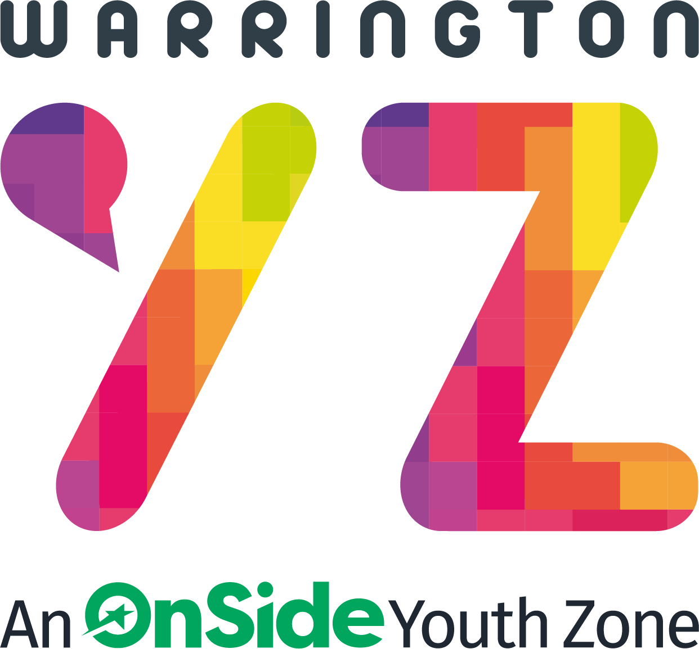
Job Title: Aspire Support Worker (No Personal Care)
Location: Fox Wood Primary school/Green Lane School
Section: Care Work – Aspire Project
Status: Part Time (fixed term for four weeks)
Salary: £5.12-£9.41 per hour age dependant.
Responsible to: Springboard Coordinator
OnSide Warrington Youth Zone is aiming to recruit highly motivated, innovative people to the role of Aspire Support Worker (No Personal Care). They will play a vital role working alongside the support staff and Aspire Club Team to provide disability holiday club provision in the Warrington area. Our programmes are focused on children and young people with additional needs aged 6 – 19.
We are looking for creative and energetic individuals to inspire, engage and motivate young people through holiday club programmes.
The successful candidate will have a proven track record of supporting and engaging young people in a youth work setting. They will have experience of working with young SEND young people to ensure the safe delivery of all sessions.
The role will encompass a diverse range of tasks and responsibilities. In return, you will receive a rewarding and challenging opportunity with a charity that is committed to the social and personal development of young people and work within a highly focussed team to contribute towards the growth of OnSide Warrington Youth Zone.
Main Responsibilities
- To help support the individual during holiday club activities on a one-to-one basis.
- To assist individuals to fulfil activities of holiday club.
- To assist with medications as prescribed by a medical professional where needed
- To keep up to date with legislation and government initiatives affecting youth work, in particular children and young people with disabilities and additional needs.
- To look after the physical, emotional, cultural and social needs of individuals attending the WYZ holiday club using a person-centred approach
- To observe the individual's choices, independence, dignity, privacy, fulfilment and other rights
- To work as part of a team to ensure the smooth running of each session.
- To develop positive, professional relationships with individuals attending the holiday club and all those we work alongside.

General Requirements:
- To be alert to issues of safeguarding and child protection, ensuring the welfare and safety of young people is promoted and safeguarded, and to report any child protection concerns to the designated Child Protection Officers using the safeguarding policies, procedures and practice (training to be provided).
- To adhere to Warrington Youth Zone policies at all times, with particular reference to Health and Safety, Child Protection and Equal Opportunities.
- Always seek to continuously improve, so that the highest quality standards are achieved.
- Work in accordance with Warrington Youth Zone’s culture, values, aims and objectives
- Act as a positive ambassador for Warrington Youth Zone at all times.

Personal Specification
- Demonstrate a physical and emotional capacity for the enthusiasm and energy that children require of their playmates – be prepared to be a playmate, support and/or facilitate a child or young person’s inclusion in activities and provide physical care supervision and get to know the children and young people who attend the Aspire Holiday club.
- Show a capacity to work within a team, to be adaptable and to work in a disciplined way in an informal environment
- Experience of working with children and young people particularly with disabled children and young people in the field of play is desirable
- An understanding of the importance of all children and young people’s need to play and how play and youth staff can support children and young people to do so
- To show commitment to the development of high quality, interesting, fun and creative play opportunities for disabled children and young people
- Prepared to attend training and to learn new skills with which to develop an understanding of good practice in play and leisure for disabled children and young people

Other Duties

To carry out any other duty within the Youth Zone provision and facility operations, and within the competencies of the post holder, as directed by your line manager or a senior manager.

Interested?
Contact us at recruitment@wyz.org.uk for the full application pack or visit the ‘Get Involved’ section of our website www.warringtonyouthzone.org or call 01925 977277.
Application Process
Closing Date:
Interview Date: TBC
Expected Start Date: 26th July 2023
Warrington Youth Zone is committed to Equal Opportunities and Safeguarding, therefore this post is conditional on satisfactory completion of an enhanced DBS disclosure and satisfactory references.
PLEASE NOTE: CV’s will not be accepted without an application form.

